And God spoke all these words: “I am the Lord your God, who brought you out of Egypt, out of the land of slavery. You shall have no other gods before me. “You shall not make for yourself an image in the form of anything in heaven above or on the earth beneath or in the waters below. You shall not bow down to them or worship them; for I, the Lord your God, am a jealous God, punishing the children for the sin of the parents to the third and fourth generation of those who hate me, but showing love to a thousand generations of those who love me and keep my commandments. You shall not misuse the name of the Lord your God, for the Lord will not hold anyone guiltless who misuses his name. Remember the Sabbath day by keeping it holy. Six days you shall labor and do all your work, but the seventh day is a sabbath to the Lord your God. On it you shall not do any work, neither you, nor your son or daughter, nor your male or female servant, nor your animals, nor any foreigner residing in your towns. For in six days the Lord made the heavens and the earth, the sea, and all that is in them, but he rested on the seventh day. Therefore, the Lord blessed the Sabbath day and made it holy. Honor your father and your mother, so that you may live long in the land the Lord your God is giving you. You shall not murder. You shall not commit adultery. You shall not steal. You shall not give false testimony against your neighbor. You shall not covet your neighbor’s house. You shall not covet your neighbor’s wife, or his male or female servant, his ox or donkey, or anything that belongs to your neighbor.” Exodus 20:1-17

He replied: “Isaiah was right when he prophesied about you hypocrites; as it is written: ‘These people honor me with their lips, but their hearts are far from me. They worship me in vain; their teachings are merely human rules.’ You have let go of the commands of God and are holding on to human traditions.” And he continued: “You have a fine way of setting aside the commands of God in order to observe your own traditions! For Moses said: ‘Honor your father and mother,’ and: ‘Anyone who curses their father or mother is to be put to death.’ But you say that if anyone declares that what might have been used to help their father or mother is Corban (that is, devoted to God), then you no longer let them do anything for their father or mother. Thus, you nullify the word of God by your tradition that you have handed down. And you do many things like that.” Mark 7:6-13
Until recently I had no idea what the “Retin-A” cream is.
For her special day Janet received an expensive tube of Retin-A from her two teenage daughters. When she shared about her gift at a luncheon with friends, they were all impressed that her girls were resourceful enough to get a prescription medication to help diminish mom’s wrinkles.
Realizing this was such a unique gift, the ladies were curious as to what they gave her for last Mother’s Day. Without a moment’s hesitation Janet replied, “The wrinkles!”

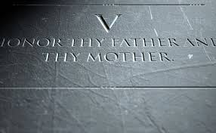
The Fifth.
1. Once upon a time, our generation, and those preceding us, at young age were familiarized with the “Ten Commandments.” They were taught not only in churches and synagogues, but even in the public schools. Unfortunately, as modern, the so-called: “enlightened” society decided to get away with God and His influence, the values, such as the ones listed in the “Ten Commandments,” were also rejected by the “rational” society. For centuries the “Ten Commandments” have been the most important Scriptures passages known by heart by the vast majority of the societies influenced by the Judeo-Christian tradition. Historically, even before the birth of Jesus, and the establishment of the Christian Church, the “Ten Commandments,” referred to as the “Mosaic Law,” were known to all the Hebrews, and served as the foundation of their religion, the Judaism. Every Jewish child learned and knew them by heart since the days of early childhood. That is not however, a case anymore, neither in the Jewish, nor in the Christian circles, and definitely it is not in the secular society, controlled by the so called “open-minded” views and the ideologies of “humanism.”
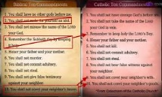
2. I understand that those of us who still know and remember the “Ten Commandments” may sometimes be a bit confused as to the numerical order of them, because the Church certainly differs in the numerical sequence of them, depending on the Church’s tradition. The first and the second commandments in most of the Protestant Churches, which follows the order of the Jewish tradition, are separated, while in the Roman Catholic tradition these two are combined into one, thus changing the numerical order of all of the commandments. To complicate the listing of them even more is the Lutheran Church’s tradition which reverses the 9th with the 10th. Nevertheless, the wording and the meaning of all of them, are the same in totality, thus are familiar to all the traditions, even if sometimes we may have a problem to quote them in the same sequence and order as the Jewish Tora does. I would also suggest, that most of us may have our own “order” of listing of the “Ten Commandments,” based on the importance they represent to us personally. We have a tendency of remembering and even quoting most of them, according to which ones we consider “more” or “less” important. In result of all this confusion, it is no wonder that the 5th is one of the most numerically “fluctuating” of all the commandments. In certain periods of time in our lives, this commandment plays rather an important role while in others a relatively insignificant one. Many young people, for example, when they return home from college cannot believe how much their parents have “matured” over these years. In their teenage years, dedicated to the revolt and rejection of the common norms, they never recognized the “maturity” of mom and dad, and now suddenly they see it and with a dose of amazement.

3. The Fifth Commandment, although known by most of us, even today, certainly is not the priority for many young people, and yet, this commandment is so very important. Do you know that the “Fifth” is the most quoted commandment in the New Testament? Among other places it is cited in the Gospels of Matthew (15:4) and Mark (7:10) as well as in Paul’s letter to the Ephesians (6:2). I find this interesting, but the question is: “why?” What is so peculiar, or so important about the 5th commandment, that makes it to be the one, mentioned the most, in the New Testament? I believe the answer is found in its implications for both, the Old and the New Testaments traditions. It is unequivocally true that the Old Testament, as well as the New Testament worlds were dominated by patriarchy, where males dominated all aspects of life, just as it still exists and is practiced in the world controlled by Islam, and I do not want, even for a second, to dispute that reality. In that world, male dominance over the females’ voice, made women’s opinions practically inconsequential, therefore, what is so powerful about the fifth commandment is that it emphases an equal importance of the mother as well as of the father in raising a child. The 5th commandment says: “honor your father and your mother,” and it shows that the children, in an early age, have learned to offer and equal respect for both of their parents. In the male dominated society, any suggestion of any form of equality between male and female, was a revolutionary idea, thus the 5th was indeed, a truly “revolutionary” commandment.
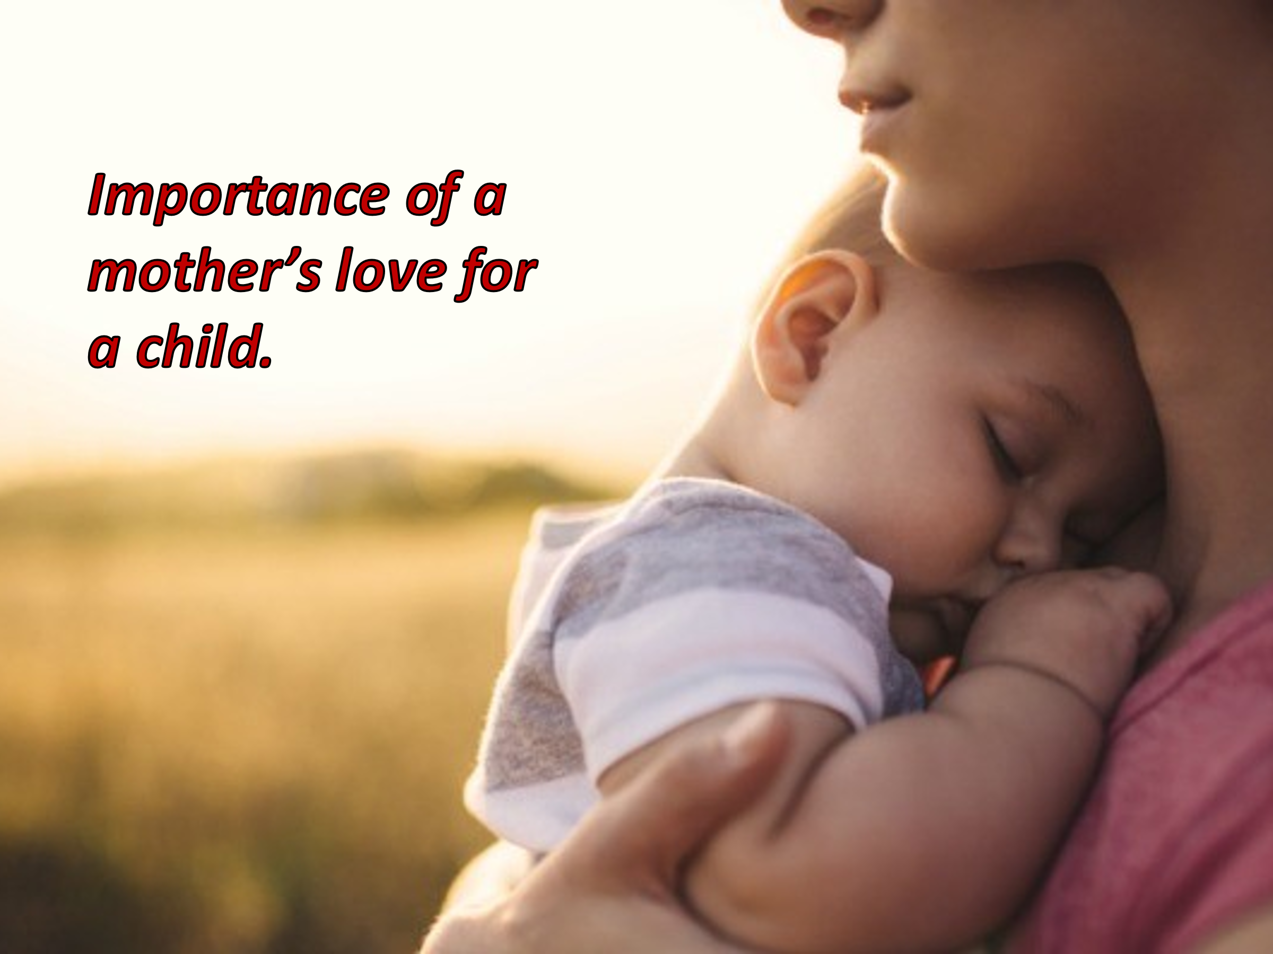
4. We must remember that this commandment is about 3500 years old, and yet it emphasizes and focuses not only on a man - the father, but also on a woman - the mother. This leads to another important factor of this commandment, which is “love,” a mutual, two-way street love, flowing from both, the parents and from a child. In many ancient cultures, the boys were taken care of by women until they reached the age of 6 or 7, but then were taken care of by a man, to learn the necessary skills to survive in the hostile world, to hunt, to provide and to defend of his own. Even boys’ religious life would begin at that time. But the significance was in the fact that his prime years were taken care of by a mother, and in that time, children would learn about love, empathy, warmth and other emotions. Today, even the modern psychology clearly indicates that love is the most important of all the emotions, in every child’s life, from the very moment of birth. This commandment, already 3500 years ago, exposed the importance of love in every child’s life. And I am not talking about the kind of love that exists between boys and girls, or men and women, but of love that exists between the children and their parents. It is the type of love that is not offered instinctively through the “blood lines,” but derives from the emotional attachment. For many orphans their foster or adoptive parents became the real loving parents, and they are the ones these children remember and call “mom” and “dad.” This love however is not something that is inherited but is learned and experienced.
5. Since this commandment says: “Honor your father and your mother,” does this mean it is addressed to the children only? Or is it directed to the adults also? It took me a while before I realized that this commandment was not given to us so we may teach it in the Sunday School or in schooling of our children, in whatever form this schooling might appear, but this is the commandment given us, the adults, as well. We might have been taught the “Ten Commandments” as children, and probably, because of this, we tend to think that the 5th commandment is given only to the children. It might seems so on surface, but consider this, even as adults we are the children to our parents. We do not like to think about this because a “child” seems to indicate vulnerability, someone who needs adult protection, and we prefer to take care of ourselves on our own, but to our parents we never cease to be their “children.” At certain point I also realized that this commandment was given to us, the adults. “Honor your father and your mother,” and do this whether you are a 5, 10, 15, 25, 50 or older. Even if our parents may not be physically present in this world. After all, we cannot and must not cease to remember who took care of us from the moment we were born to the time we left home. We must not forget who was looking after us when we were small babies and when we were teenagers, when we were sick or suffered first emotional loss. Our parents always took care of us. Only upon leaving home, when we grew up and when we had our own children, we finally realized the importance of our parents, thus “honoring them” begun to make sense. In the end, I believe we expect the same from our children when they grow up.
6. Bible does not say: “honor your daughter or your son,” although Paul says: “and, fathers, do not provoke your children to anger, but bring them up in the discipline and instruction of the Lord.” The Bible says: “honor your father and your mother.” I wonder if this should not be the most important commandment in how we relate to others. Maybe it should be the commandment everyone would always remember, whether we are children, adolescents or adults. This is a very important issue in modern world. Not so long-ago, most parents, when they became elderly, were taken care of by the children, while today it is so very common to send them to the “old folks homes.” Please, do not misunderstand me, sometimes the total care of our elderly requires the “nursing home” care, and may be offered only is such homes, but today, unfortunately, such a decision is very often made simply because of the “convenience.” I worked with elderly people in many “nursing homes,” and I have seen how much they “missed” their children and so often felt left alone, because of the young generation’s life “busyness.” “Honor thy father and thy mother,” these are the words of respect, respect for those who dedicated their lives to raise us, to help us to flourish, to build our “life.” For our parents we are their offspring’s, and will always remain as such, even if sometimes there is no “blood line relationship” involved.
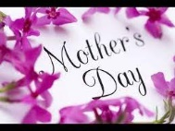
7. Today is the “Mother’s Day,” a day we dedicate to our “mothers,” but have you ever noticed how often the Bible refers to God as a “loving father,” while at the same time describing His love to “motherly love?” Psalm 91 says: “He will cover you with His feathers, and under His wings you will find refuge.” Isaiah writes: “Can a mother forget the baby at her breast and have no compassion on the child she has borne? Though she may forget, I will not forget you!” Listen once again to the words of Jesus who in Matthew and Luke’s Gospels says: “How often would I have gathered your children together as a hen gathers her brood under her wings, and you were not willing!” These are only a few illustrations showing God’s love being as powerful as the true mother’s love for her children. How powerful such love is probably the best described in the story of the two women, each telling king Salomon that this is “her child?” Surely, we know, only one of them was a real mother, and we know from that story who this mother was. On this “Mother’s Day” we are once again encouraged and commanded to “honor our mothers,” and to honor them not only once a year, on the second Sunday in May, but to honor them every day, just as we should thank and honor our God every day, for everything He bestowed upon us, in a physical as well as in a spiritual sense.
8. So, as I indicated earlier, this commandment focuses on us – the adults, to keep honoring our parents and their commitment. Over the ages this commandment might have been adjusted in terms of who it is directed to, but the children were not the original recipients of this commandment, for the “Fifth” is a part of a larger “package,” one that Moses brought down from the Mt. Sinai, not to the children in the Hebrews camp, but to the “Children of God,” to all the Hebrews, and eventually they were passed on to us, the “Children of God” through the sacrifice of Jesus. Yes, it means it is us who are to “honor our parents,” just as we are to “honor our God.” The “Ten Commandments” are the vital part of our covenant with God, and they all apply to both the “Old” as well as the “New” covenants. Jesus teaches us how important love is in our lives, and the way I see it, the 5th Commandment, is the “Commandment of Love.” In the end, I do not care what the “modern” society says, what the crooked politicians and twisted judiciary of this country rule, the “Commandment of Love,” just as all of the “Ten Commandments,” is still valid, well, and alive, despite the constant call for the eradication of all of them. Just as we cannot eradicate the role of our mothers in our life, we cannot eradicate our love for God and His commandments either.

