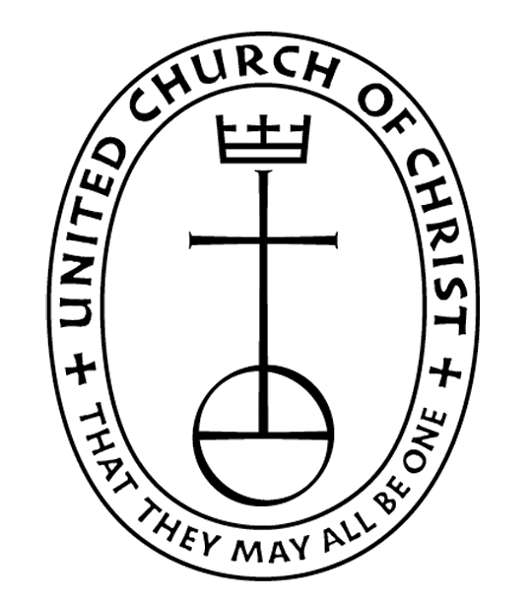


The EPISTLES OF FAITH

FAITH UNITED CHURCH OF CHRIST
628 Clermont Street
Antigo, Wisconsin 54409
Phone: 715-623-5717
Church E-Mail Address: faithucc@frontier.com
Rev. Dr. Wes A. Jedras: wjedras@hotmail.com
Church Website: www.antigofaithucc.org
Administrative Assistant: Laurie Hackbarth
Church Office Hours: Monday Closed;
Tuesday through Thursday 8:30 AM - 2:30 PM; Friday - Closed
Church Council Chair: Sue Moseman

SUNDAY SCHEDULE
Worship: 10:30 a.m.

You are invited - Bring a friend!

A

A

April
2026
A Story from Pastor Wes:

The Easter Miracle
(True story by Debbie Orrico)

Grandma Lily was a very special woman with a fierce streak of independence that showed itself at an early age. When she was just 16 years old, she eloped with a 28-year-old man. Although her family placed bets that this union would not last, she proved herself by becoming a loving wife, and a mother to 8 children.

That is, until her world was turned upside down. Grandpa John passed away right before the depression, leaving Grandma Lily alone with 8 young children to raise. It was a tremendous struggle. The family was dirt poor. The children had to sleep 3 to a bed. The good clothes were worn by the first ones up in the morning. The rest had to make do with the patched hand-me downs that were left behind. Some clothing was even made from flour sacks. During the cold Connecticut winters, none of the children had boots, so if the ground was wet or snow-covered, Grandma Lily would line her children’s shoes with newspapers and canvas to keep their feet warm and dry. Meals were meager, with meat served only once or twice a month.

Throughout the years, Grandma Lily longed for Grandpa John, often spending hours at the cemetery, planting flowers at his graveside and remembering their good times together. Some fifty odd years after Grandpa John passed away, as Grandma Lily returned from the cemetery, she noticed that her wedding band was missing. She was frantic! It was the only tangible thing she had left to remember her husband. It was a symbol of their eternal love. She quickly went back to the cemetery, but the ring was nowhere to be found. Her children also made several of the searches of the area in vain. The ring was gone — vanished into thin air! Grandma Lily was absolutely heartbroken.

The next Mother’s Day, her children gifted her with a new wedding band. Although Grandma Lily was touched by the thought that went into the gift, it made her sad to realize her original wedding band was gone forever.

The following Easter, Grandma Lily went to the cemetery accompanied by her daughter Grace. They stood side by side, silently saying their prayers for Grandpa John. They admired the flowers, especially the Easter Lilies that were standing tall and proud, sending their fragrance out for all to enjoy. Out of the corner of her eye, Grace noticed a glint of something shiny, and pointed it out to Grandma Lily. Since she was the closest to the plant, Grandma Lily bent over, and examined the leaves of the lily plant. She could not believe her eyes when she saw what it was. There, brilliantly glowing in the sunlight was her original wedding band! The one that she had lost the previous year… the symbol of eternal love… the one that her husband had given her more than fifty years before!

The Easter season is known as a time of miracles, and of resurrection. For Grandma Lily, the miracle WAS a resurrection…her wedding band, resurrected on a lily plant. The fact that my Grandma’s name was Lily makes this story even more special!

Grandma Lily passed away a few years later. We made sure that we buried her with her original wedding band, and kept her second wedding band as a family keepsake.

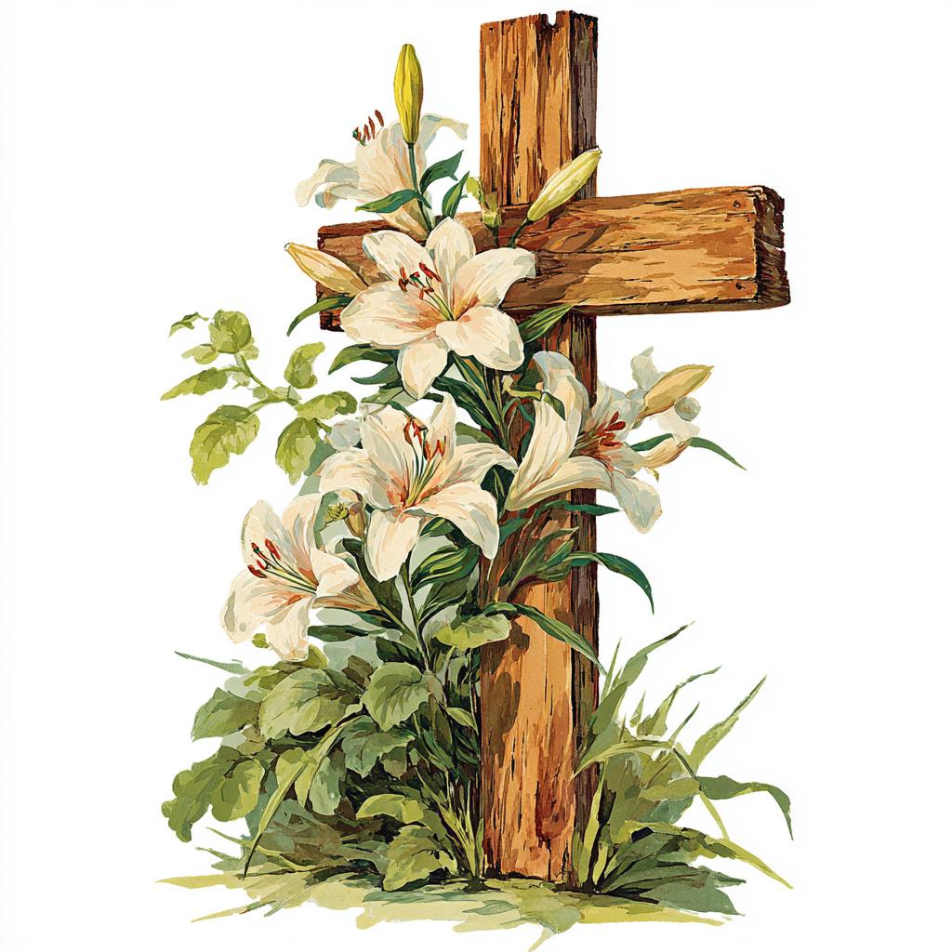

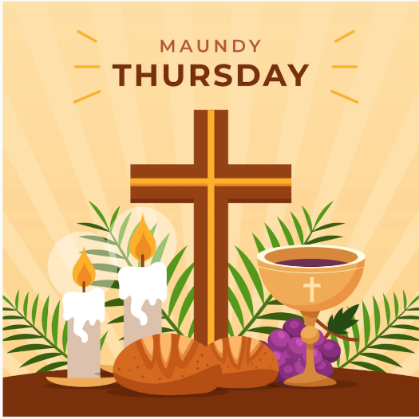

April 2nd
5 p.m. Soup Supper
6 p.m. Maundy Thursday Service with Communion



Join us Easter morning for
breakfast @ 9 a.m.

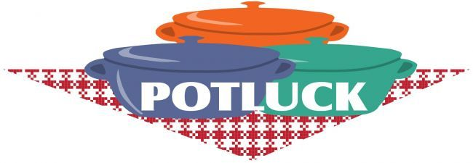

Sunday, April 26th
Please bring a dish to pass.


Sunday, April 19



Beth Kelly
528 Flight Road
Apt 218
Antigo, WI 54409


3. Courtney Montgomery
12. Matt Rasmussen
21. Lincoln Zingler



Laurie will be out of the office April 7th through April 9th.
She will be back in the office on
April 14th.



May Epistle articles are due Thursday, April 16th.



(Members and Special Friends of the Church) Susan Black; Patti Hilger

(Family/friends of members) Lindsey Beck; Ed Hilger;

We pray for our military, especially Kassandra Derlein; Ben Glowacki; Padraic Kelly and William Ryan Kelly for their protection and safe return, as well as healing for those who have been injured and are recovering.

We pray for the people suffering from the tragedies of war and for the people recovering from any natural disasters.


Every second Sunday of the month is designated as “Mission Sunday.” Instead of collecting for individual missions throughout the year, once a month we will have a general collection for OCWM and the four missions.
One of the four missions is Strengthen the Church. Strengthen the Church is a special mission offering to reimagine and build the future of the UCC. Shared at the conference and national levels, STC largely supports youth ministries and full-time leaders for new churches in parts of the country where the UCC does not have a strong presence. It also provides support for existing church’s new initiatives
The work of the church, the body of Christ, is most profoundly demonstrated through mission outreach. Please give with generosity and compassion. (If you prefer to give to a specific mission, please put your contribution in an envelope and mark the envelope with your selection.)

