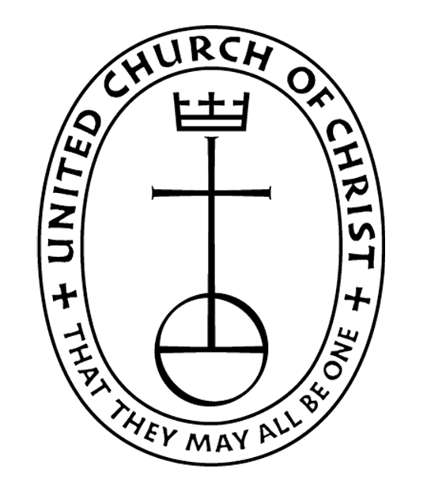
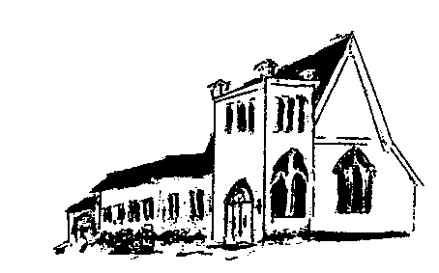

The EPISTLES OF FAITH

FAITH UNITED CHURCH OF CHRIST
628 Clermont Street
Antigo, Wisconsin 54409
Phone: 715-623-5717
Church E-Mail Address: faithucc@frontier.com
Rev. Dr. Wes A. Jedras: wjedras@hotmail.com
Church Website: www.antigofaithucc.org
Administrative Assistant: Laurie Hackbarth
Church Office Hours: Monday Closed;
Tuesday through Thursday 8:30 AM - 2:30 PM; Friday - Closed
Church Council Chair: Sue Moseman

SUNDAY SCHEDULE
Worship: 10:30 a.m.

You are invited - Bring a friend!

A

A



2026

A Story from Pastor Wes:

What lies on the other side of life?

A sick man turned to his doctor, as he was preparing to leave the examination room and said, “Doctor, I am afraid to die. Tell me what lies on the other side.”

Very quietly, the doctor said, “I don’t know.”

“You don’t know? You, a Christian man, do not know what is on the other side?”

The doctor was holding the handle of the door; on the other side came a sound of scratching and whining, and as he opened the door, a dog sprang into the room with his tail wagging and an eager show of gladness.

Turning to the patient, the doctor said, “Did you notice my dog? He’s never been in this room before. He didn’t know what was inside… He knew nothing except that his master was here, and when the door opened, he sprang in without fear. I know little of what is on the other side of death, but I do know one thing. I know my Master is there and that is enough.”

To know who and what we are committed to is enough, we do not need to have the full answer to all the questions life ask. We need to keep the direction and as we encounter whatever life throws at us we deal with it when it comes


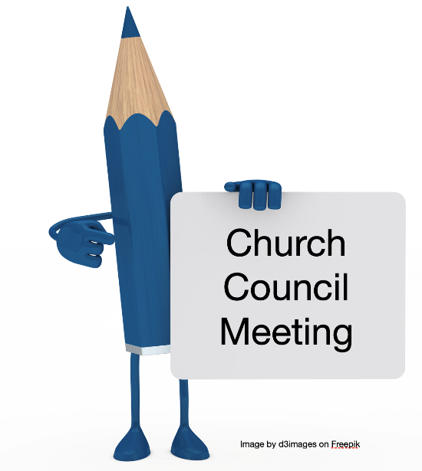

Brat & Pie Sale
Friday, May 22nd
10 a.m. – 1 p.m.
@ Lakeside
Market

Sunday, May 17th

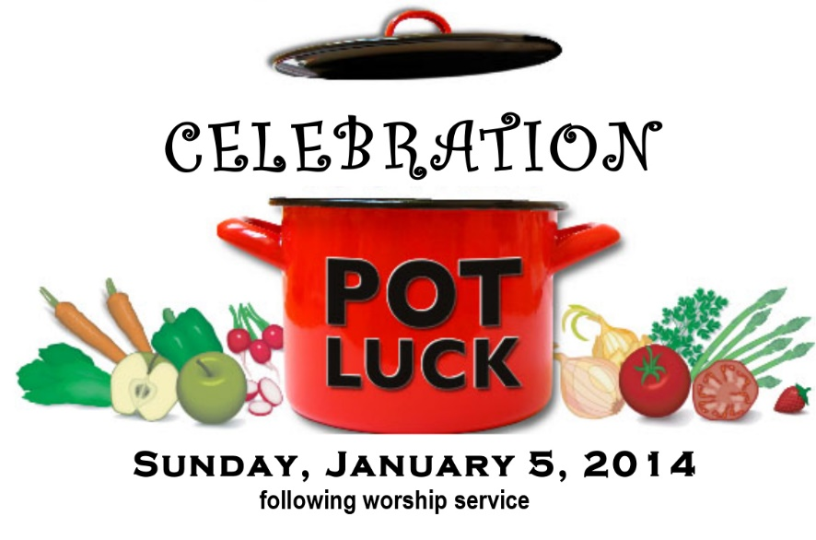

Sunday, May 24th
This will be the last potluck until Fall.
Please bring a dish to pass.



Mission Sunday

Every second Sunday of the month (May 10) is designated as “Mission Sunday.” Instead of collecting for individual missions throughout the year, once a month we will have a general collection for OCWM and the four missions.
One of the four missions is Strengthen the Church. The Strengthen the Church Offering furthers the work of our conferences and the national UCC as we work together to strengthen and renew existing congregations, fund leadership development, and provide exciting new programs for youth and young adults. The offering is divided with 50% staying regionally within your conference and 50% supporting the National Ministries.
The work of the church, the body of Christ, is most profoundly demonstrated through mission outreach. Please give with generosity and compassion. (If you prefer to give to a specific mission, please put your contribution in an envelope and mark the envelope with your selection.)

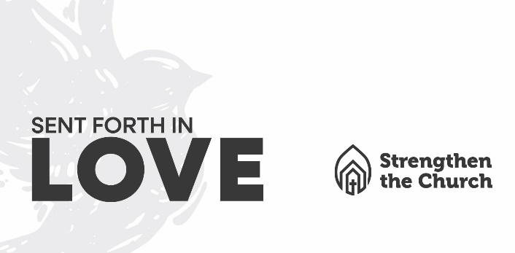



4. Arlene King
5. Lolita McKinnon
9. Owen Andes
12. Sara Rasmussen
17. Sally Schroeder
26. Jack Wurtinger Jr.
29. Karissa Derlein

May

Anniversaries

7. Steve & Lynn Fermanich
11. Matt & Sara Rasmussen


June Epistle articles are
due May 21st.

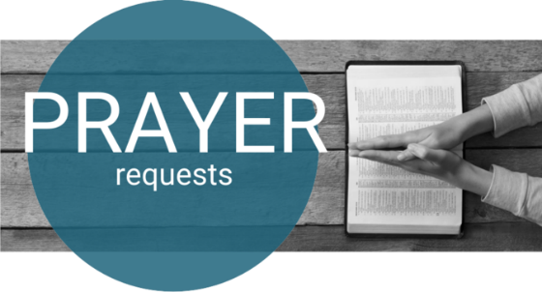

(Members and Special Friends of the Church) Susan Black; Patti Hilger

(Family/friends of members) Lindsey Beck; Tom Hackbarth; Ed Hilger

We pray for our military, especially Kassandra Derlein; Ben Glowacki; Padraic Kelly and William Ryan Kelly for their protection and safe return, as well as healing for those who have been injured and are recovering.

We pray for the people suffering from the tragedies of war and for the people recovering from any natural disasters.

